# Thomas Alfiandes

Jl. Mampang Prapatan VI/ Jl A no. 10B

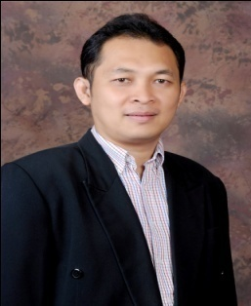Tegal Parang Mampang Jakarta Raya 12790 Indonesia

South Jakarta 12790

HP: +62 818148698

[thomas.alfiandes@gmail.com](mailto:thomas.alfiandes@gmail.com)

# Position desired: Director Business Development

**SUMMARY OF QUALIFICATIONS**

Highly experienced in Digital Solution through Omni Channel Store which it’s features and benefits similar with Payment Gate Solution, Digital Marketing and Customer’s experience through multichannel devices. Started career as IT Infrastructure Consultant Sales to develop vertical market needs and until as Country Manager Toshiba Global Commerce Solution Inc. to implement software from the back office to the boardroom, warehouse to storefront by using digital technology and Omni channel concept . This experience enables me have deep knowledge of spectrum of technology until the digital technology through Retail Solution. Since 2008 I have been handling Retail Solution, my roles and responsibilities lead sales, marketing, operation, innovative solution, implementation and services, so I strong believe that I am the right person to fill the position as Director Business Development.

**PROFESIONAL EXPERIENCE**

**Oct 2013 – Country Manager for Sales and Services for Toshiba Global Commerce Solution Inc. (Toshiba acquired Retail Solution System since November 2012) and working in the IBM office. (Provide M-POS, POS, Kiosk + EFT Hardware and Enterprise Retail Solution through Digital Technologies and e-Commerce)**

Duties :

* Lead all operational, sales and solution process in Indonesia Country
* Meeting and Presentation to decision maker such as Chief Marketing Officer (CMO), CFO, CEO, CIO or other executives.
* Established and engaged Partner Business Solution and Strategic Accounts
* Manage and lead both of overseas team and local team for innovative technology (Overseas Matrix Organization)
* Business Strategy Plan, Marketing Strategy Plan, Partner Plan and Strategic Account Plan
* Monitor client contract agreement, Scope of Work and Project Delivery
* Work closely with Account Manager & Solution Team through conduct cross selling products and solutions.

Achievement :

* Established strong engagement with Distributor, Partner and Retail, Telco and Financial & Banking Industry with Million USD transaction such as Lippo Group, Trans Group, Wing Group, MAP Group, Ramayana, Group or others merchants
* Established local support by working closely with Partner Business Solution for implementation and project delivery.
* Engaged Retail, Banking, Telco & Business Partner Solution and Alliance Community through Toshiba Global Commerce Seminar
* Create Solution go to market
* Retail Solution for Retailers which working closely with the biggest Bank such as BCA, Bank Danamon, BNI, Mandiri, Mega, UOB, CIMB Niaga etc.
* Kiosk for Hotel, Airport and Banking through Partner Business Solution
* Cinema Solution for Kiosk, Digital Ticketing, POS for Food and Beverage, Electronics Payment, Electronic Voucher etc.
* Telco Retail Solution by using pulse electronic payment for merchants
* Drive Thru Solution for Convenience Store etc.

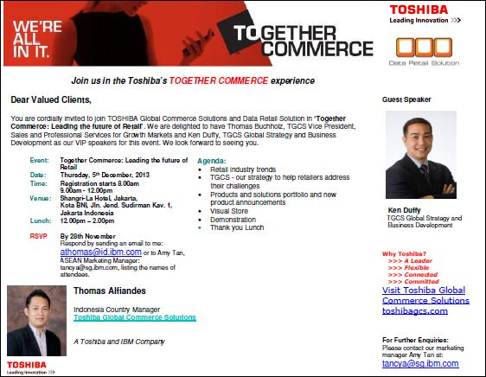

Report to ASEAN Sales Director

**Jan 11- Aug 13 Genie Technology Inc. as Business Development Manager for Indonesia Country ( Retail Pro Software, NCR Aloha Software, JDA Software and Qlik View Business Intelligence). Headquarter in Manila Philippine.**

**Duties :**

* As single point contact products and solutions
* Maintain good relationship across level Top 100 Retail Organization through CEO, CTO, CMO, CFO and function people such Merchandise, Marketing, Sales Operation, Purchasing etc.
* Maintain solid pipeline of opportunity through update database
* Conduct sales process through Business Process Request Interview, Presentation, allocation resource, budgeting, professional proposal until deal contract agreement.
* Create Business Plan and Marketing Strategy for products, solutions and support in related with Customer and Market requirement

Achievement :

* Closing deal contract with Retail Companies by Million USD Transaction
* Established Retail and Banking Merchant Payment Ecosystem and promoted the company in Retail Community successfully.

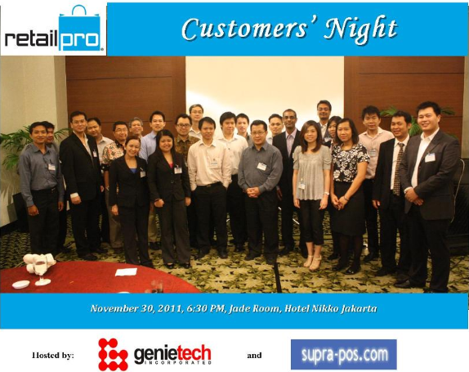

Report to COO in Manila

**Jan 10–  Dec 10 ETP International Pte Ltd as Country Sales Director.**

**Duties:**

* Maintain good relationship across level in Top 60 Retail Organization ( CEO, CMO, CIO, IT Director and Senior Manager) through Solid Pipeline Database
* Making Sales Investment Approval (Sales Process Steps Methodology such as provide business requirement interview, Account Strategy, budgeting, allocate resources, POC, professional proposal until deal contract agreement).
* Professional Presentation, Proposal until Project Delivery.

Report to Regional Sales Director

Yearly Quota Target for Indonesia Country: US$ 2 Million

Achievement

* Dealing contract with the biggest retail companies in Indonesia with Million Dollar Transaction such as Trikomsel, MAP, Everbest etc.
* Working closely with Banking EDC Solution for EFT

**May 08-Dec 09 PT NEC Indonesia as Sales Manager for Enterprise Solution**

Duties :

* Orchestra Sales Team ,Software Team, Network Team and Post Delivery Team into total solution
* Maintains Strategic Account from Retail and Consumer Product Group Companies both locally and globally
* Managed and allocated resource locally and regionally and work closely with them to provide marketing strategy for products and solutions such as (CPG , Retail, Education, Cloud Computing Services Solution ).
* Create Business and Marketing Strategy to Products, Solution and Services in related with customers and market segment
* Lead Sales & Budgeting Report Meeting every month

Achievement:

* Established strong relationship lifecycle solution selling for Manufacturing, Consumer Good, Banking, Government Oil and Retail :
* PT Ajinomoto Indonesia for Japanese Manufacturing Software and Mobility of Sales Force Automation amount to 3 Million USD
* PT Mandom Indonesia for Japanese Manufacturing Software and Mobility of Sales Force Automation amount to 2 Million USD
* PT Bridgestone Tire Indonesia ERP SAP and HR Solution amount to 1.5 Million USD
* PT Komatsu Indonesia by using ERP SAP amount to 2 Million USD
* Project IT Platform for Toyota, Yamaha, Daihatsu Automotive company
* Deal contract with PT Modern Group for Seven Eleven Convenience Strong by using NEC Retail System Software integrated with Microsoft Dynamic AX is around 5 Million USD
* Project BP Migas (Government Institution for Oil & Gas Sector ) for Gasoline Quota System for Driver and Fisherman Citizen
* Build strong relationship with Consumer Product Group and Retail Companies by conduct IT Seminar.
* Project of Flash Card for BCA Bank by using Smart Card

Report to VP Sales

**Oct 07 – Apr 08 Lucent Alcatel Business Partner and Distributor: Provide Data, Voice and Security Solution. As Senior Account Manager for Lucent Alcatel Enterprise Solution**

.

* Manage Strategic Accounts and hunting New Accounts
* Working closely with Telco Account Manager to provide solution to their clients

**Achievement:** Banking, Hotel and Distribution projects amount to US$ 5 Million

Some projects working closely with other Telco Service Providers and System Integrator

**Jan 06 – Sept 07 Senior Business Development PT Trimera Media Utama ( Joint Venture with PT Telkom Indonesia ) Product : Commerce One is similar with Ariba and Bayan Trade**

Provide : Procurement Service Provider Consultant ( Supply Chains Management , Business Intelligent and Collaboration by using Cloud Computing Services ) and Telecommunication Infrastructure.

* Working closely with Telkom Indonesia to develop business the biggest companies in Indonesia especially State Company or BUMN and the biggest Banks with huge transaction of buying
* Monitoring Project Delivery, Transforming and Change Management

Achievement

* Deal with Telecommunication Companies, Bank, Mining and BUMN Companies with Million USD Transaction.
* **Established with Government Body in conducting e-Procurement Solution for all Government Department and Enterprise Companies.**

**Jan 04 – Dec 05 Senior Telco Strategic Account Manager for PT. Metrodata Solusi Infomatika (Sun Microsystems Distributor and Solution Provider)**

**which handled XL Axiata and Indosat Group**

**Duties :**

* Actively manage all senior level relationships with clients and senior executives at Board and CEO level.
* Planning and management of all aspects of customer engagement and delivery including financial performance and service delivery on large project
* Create and manage the appropriate delivery, service based contract agreement and company financial

**Achievement :**

* Closing deal contract agreement with Sun Microsystem Principal and XL Axiata for project Data Center amount to 8.6 Million USD

Business Case and Financial Model:

* Hardware Sun Enterprise Server for 120 processors and Storage
* Service Level Agreement : Platinum 24 hours x 7 day amount to 500K USD

Business Model: ( Change CAPEX to OPEX )

CAPEX x 2% for 24 months which XL Axiata pay per month as OPEX

* Fulfilment Projects are amount to 4 Million USD

* Indosat Projects for Telecommunication Business Division and Corporate Business Division for Indosat is amount to 6 million USD

Report to Sales Director

**Jan 00- Dec 03 Business Development Manager PT. Texascom Hitek System ( IT & Telecommunication Total Solution )**

Product and Solution: Video Conference Solution, ISP Solution, Data and Voice Solution, Network Analyzer and Telco Solution.

**Duties:**

* Develop Telco and Banking Sector into Strategic Account by providing various solution.
* Lead Account Manager Team and Pre-Sales
* Working with matrix team both internal and external.

Achievement:

* Successfully to engage Banking and Telco Sector by get contract more than 20 Million USD per year through providing various solutions and services

EDUCATION

* Management Informatics, University of Bina Nusantara
* Harvard Business Leadership from Harvard

SOCIAL ACTIVITIES

1. Member of Toastmasters International by serving variety roles since 2005
2. Take part of Speech Contest which one of them become Speech Contest Champion
3. Participant as speaker for Digital Technology Events , Public Speaking Events and Transformation Technology for Enterprise Companies.

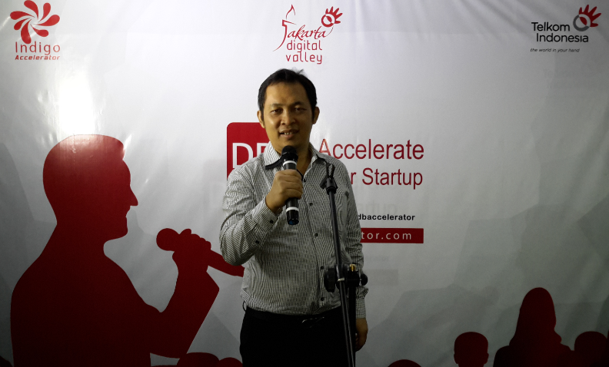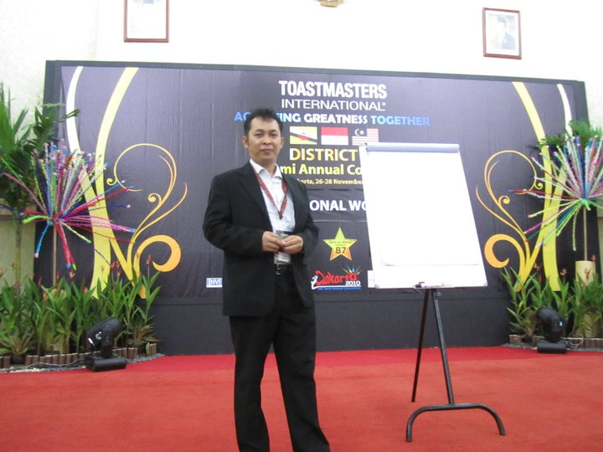

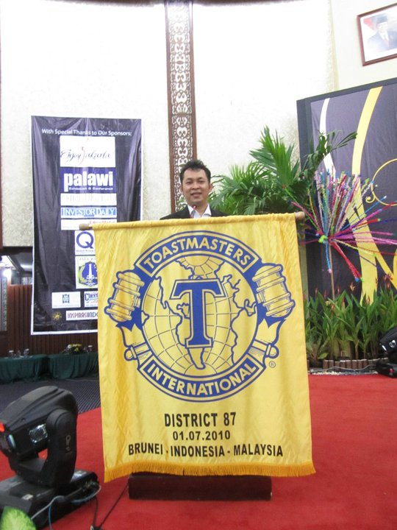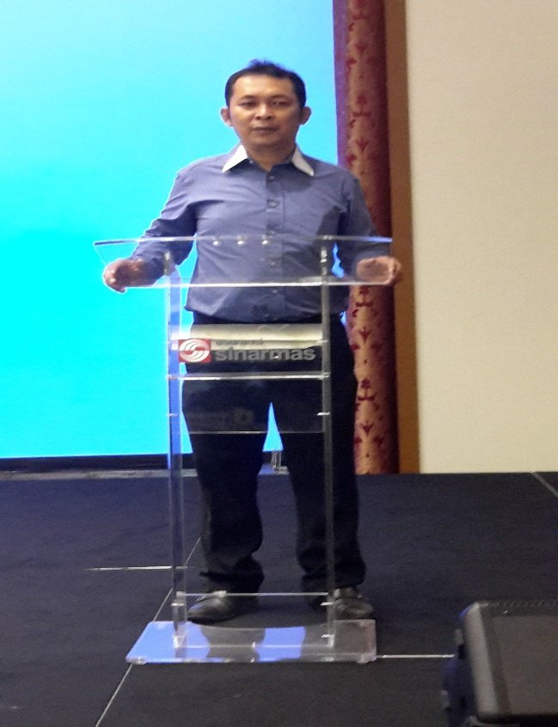

TRAINING AND SEMINAR

1. SUN, ORACLE, SAP Seminar and Training from 2004

SUN Microsystems

2. SAP Negotiation Skills Training from SAP Indonesia 2004

3. SAP Business One Training from SAP Indonesia 2004

4. Procurement Application Training from Commerce One 2006

(Outsourcing, e-Auction and SCM) similar with Ariba and Bayan Trade

5. Sales Force Automation & ERP Manufacturing Training from 2009

NEC Malaysia and Japan

6. Smart Card, RFID, and Infrastructure Solution Training 2009

7. NEC Retail System Application from NEC Singapore 2009

8. ETP Enterprise Retail System Application from ETP Headquarter 2010

9. Lawson ERP Products and Solution Training from ETP Headquarter 2010

10. Sales Investment Approval ( Sales Process Methodology )

from ETP Headquarter Singapore 2010

11. ETP Implementation Methodology Training from ETP Headquarter 2010

12. Retail Concept from Retail Pro Inc. 2011

13. Merchandise System from Genie Technology Inc. Philippines 2011

14. Retail Pro Software from Retail Pro Inc. 2011

15. Retail Analytic Training from Qlik View 2012

16. Toshiba Omni Channel Store Software (Online Stores) Training 2013

17. Toshiba Visual Store Software Training 2013

18. Super Market and Dept. Store Training by TGCS. Inc. IBM Philippines 2013

19. Omni Channel Banking and Card Center Banking Solution 2013

20. Design Card Center System by using Smart Card for BRI Bank

SKILLS

Please see based on recommendation on Linked-in

Language : Indonesia, English and Asia Country Dialect such as Javanese, Chinese (Hakka) and Malay.

REFERENCE:

Mr. Santoso Lim Head of Bank Central Asia Card Center

Mr. Ingermar H. Djaffri Head of Internet and Mobile Banking at PT UOB Bank Indonesia

Mr. Andrei Widjaja Senior Vice President DBS Bank in Singapore or the others Banking Executives

HOBBIES:

Golf, Traveling, Tennis, Karaoke or Singing, Rafting, Badminton and Public Speaking